**Introduction to Computer Science – Harvard’s CS50**

1. **Computational Thinking & Scratch – Intro to Computer Science(week 0)**

Computer science is about problem solving

H I (letter ascii)

72 73 (decimal numbers)

1001000 1001001 (binary 8 bit)

Abstraction – converting lower level details into more simplified version and focus on problem solving

Since there are so many languages that cannot be represented by 8 bit(256 different type of possibilities), now we use Unicode or utf-8 which uses 16 bit(2 to 16th power or 65536 different possibilities).

Rgb – a dot, pixel, uses three byte per pixel, how many red, how many green, how many blue per pixel.

An image is a group of pixels using three bytes(24 bit) in total of kilobytes, megabytes, and so fourth.

A video is a collection of images, 24 fps(frames per second) example, showing 24 images per second, showing a sequence of static images and makes it look like a moving video.

Videos -> images -> colors -> bits -> frequency of electricity

Input -> algorithms -> output

Pseudo code – a simplified programming language

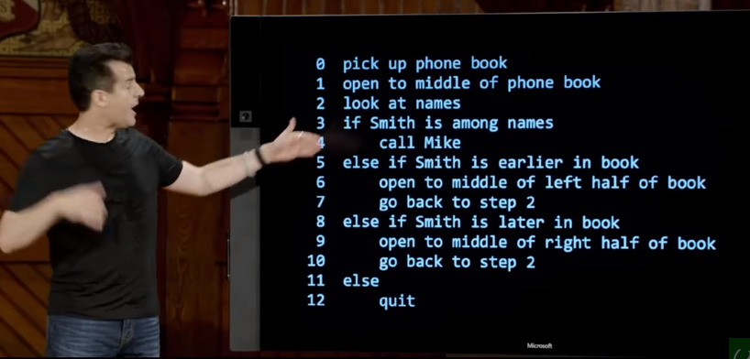 verbs here are functions, questions like if else if are conditions, smith is among names is Boolean expression, go back to step2 loops

Gigahertz – GHz is a unit of measurement for AC(alternating current) or em(electromagnetic) wave frequencies equal to one billion hertz.

1. **C Programming Language(week 1)**

Now a day, computers are performing billions of things in a second gigahertz speed, a more readable code is more preferred in some cases.

Input | Source code – code we humans have written using java, c, python

Compiler

Output | Machine code – 0 and 1s

Ram – temporary storage, has finite number of transistors which means there are finite of values that can be represented and stored accurately. For example, when you divide a number and add 50 more decimal place holders, the number that is displaced is imprecision, very micro value but still imprecision. For this reason finance displays dollars up to the thousands place, because back in the days when this was not obvious, people made money by adding up penny values.

When value reaches its’ max value, it overflows and returns to the beginning.

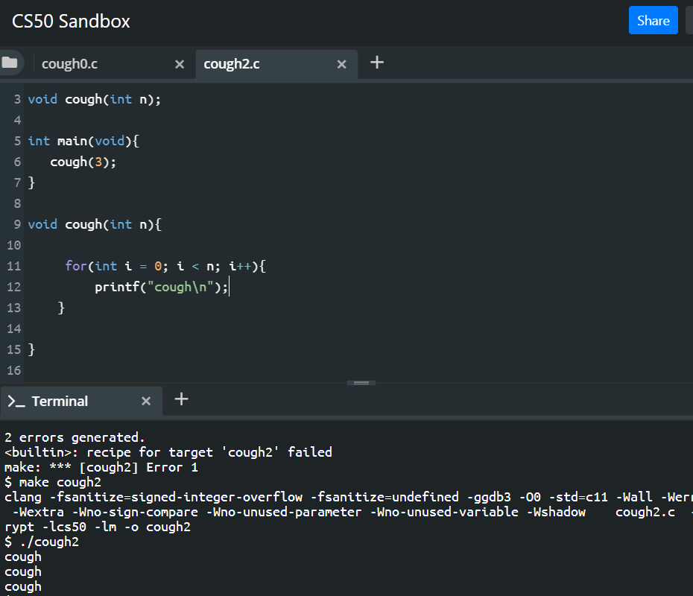

Cs50 sandbox

Problem sets

1. **Arrays and Sorting Algorithms (week2)**

Preprocessing – #include <stdio.h>

Compiling - programming language converts codes to assembly language for computer to understand

Assembling – using assembling code and converts to 10101010100101001010s(machine code, object code)

Linking – linking step links all the imported files, stdio.h + cs50.h + yourfile.h.

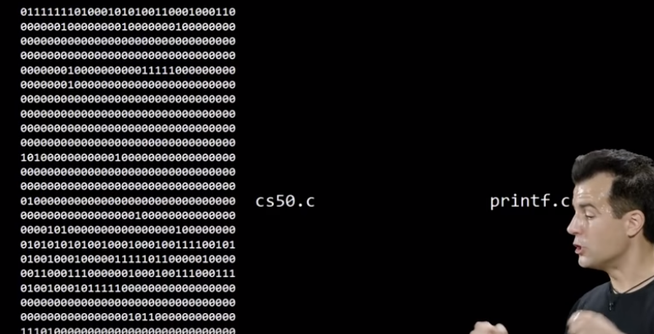

These days, people call these four steps compiling to be general.

Ram, random access memory, only runs when electricity is being charged to the device. This is the place where all the programs store memory temporary, copying the data from physical storage device and pasting it to ram. Much faster to access file from ram than from physical storage space every time you access a file.

Continuous memory is represented as an array. Array helps design wise and helps sufficiency.

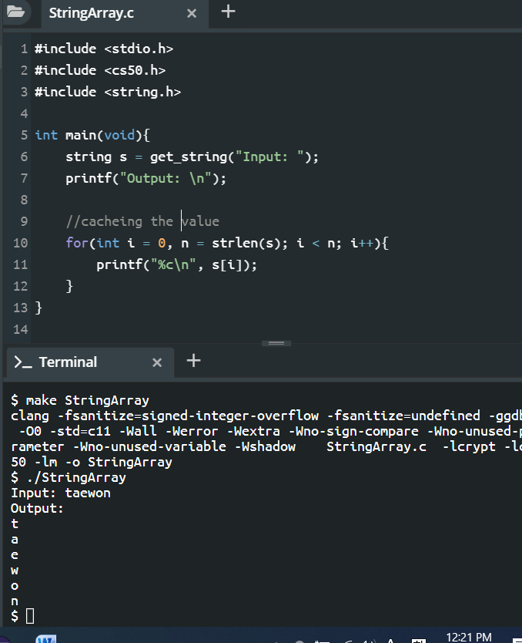

Printing one character at a time

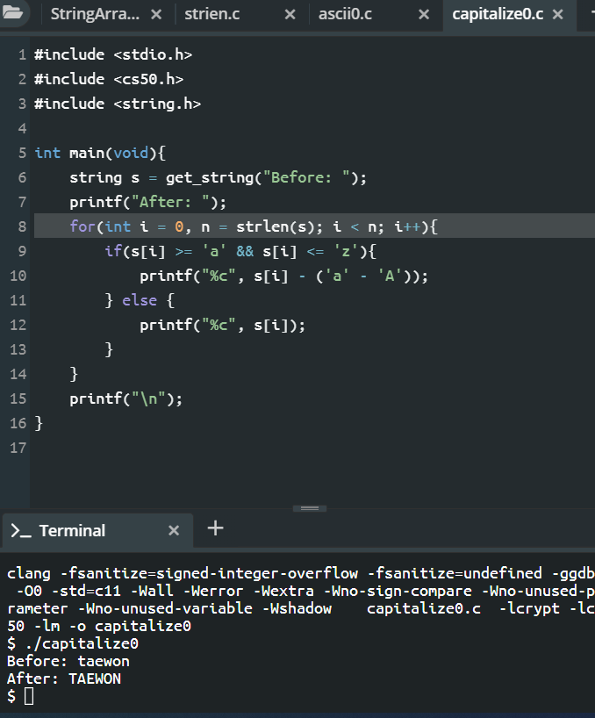

Capitalizing all characters

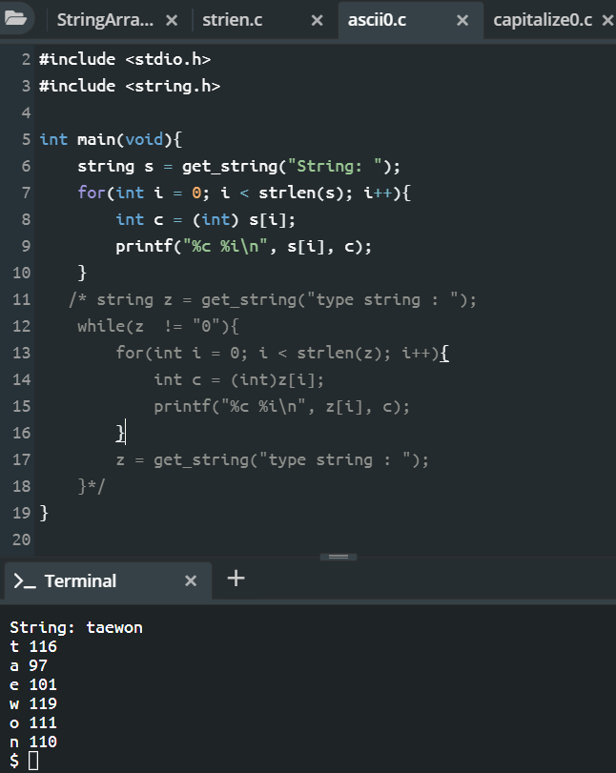

Printing ascii per character

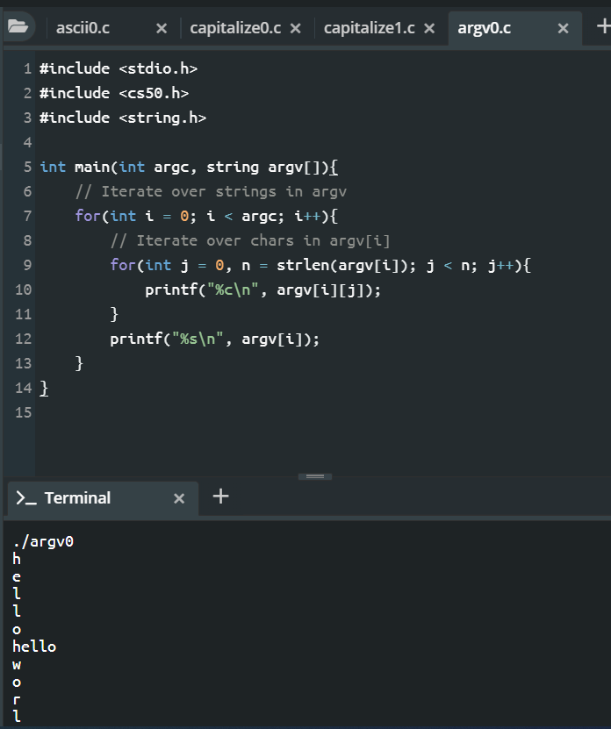

Prints typed arguments including program name and types all character of that argument

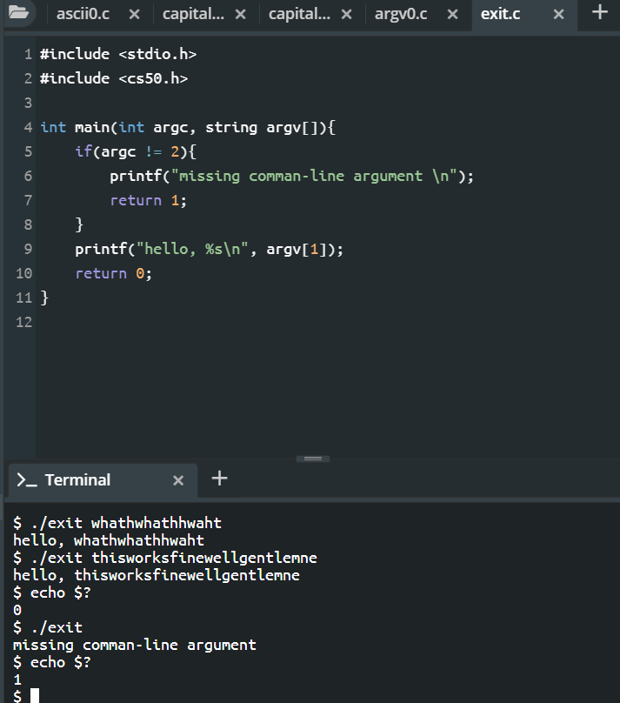

Main contains return key, just implicitly. For example, when an error occurs, a number might appear like -27, a programmer has defined the error as return -27 for that certain problem.

Bubble sort – repeatedly swapping the adjacent element if they are in the wrong order. For every turn, the searching size will decrease from the last place of an array.

Selection sort – repeatedly finding the minimum element from unsorted order. For every turn, the first place of an array increases.

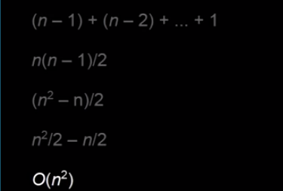

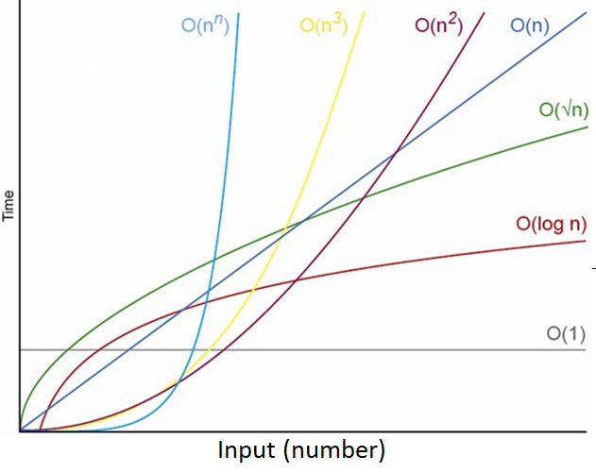

Merge sort - a divide and conquer algorithm, it divides the array in two halves, and if the array is sorted, it merges with sorted arrays. O(n log n)

Insertion sort, gnome sort both have O(n^2) time complexity.

1. **Memory(week 3)**

Compiling contains four steps, preprocessing, compiling, assembling and linking.

First convert a source code into required functions, like for instance in c, read hashtags and copy and past files.

Second step is compiling, convert source code into assembling codes.

Third step is assembling, converting assembling codes into machine codes, 1s and 0s.

Last, link all files into 0s and 1s.

Programmers don’t like to be tedious all the times, instead use powerful tools to assist them when programming. From cs50 sandbox, we will now use cs50 ide(integrated development environment)

Terminal commands

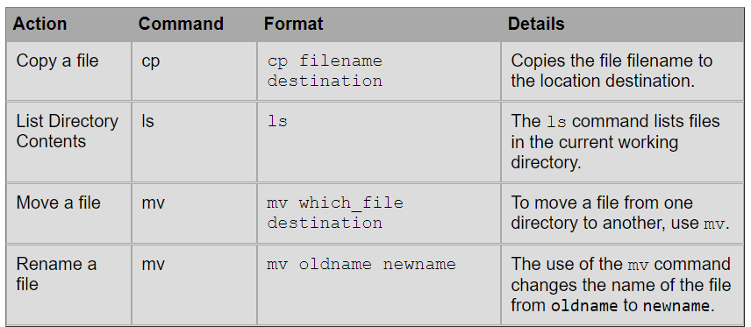

Ls – shows list of files in current location

Cd – redirect current location(cd .. for back, cd filename to go to that directory)

Rm – to remove a file

Mkdir – makes folder

Rmdir – removes directory

Make – creates a runnable code

./ - runs the source code

Touch – creates a file

Utilize the power of a debugger! Will save you minutes and hours with a problem.

String is actually an array of characters with null at the back.

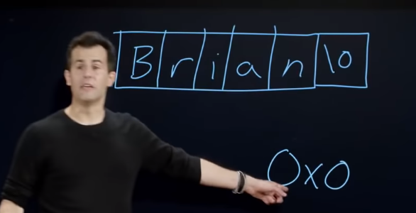  
0x0 is null! Could be seen at debugger

Data type can only receive certain size of a byte. String returns memory location.

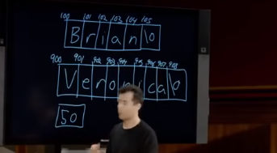

brian returns 100th value in memory while veronica returns 900th value in memory.

String is a synonym of char *. * means an address of a something to its left, char * will mean character’s address. A pointer is an address.

When nothing is specified in the main function, it automatically returns 0 if it runs successfully.

Segmentation fault means user touched memory that user should not have. Returning one if null like above helps to prevent memory problems.

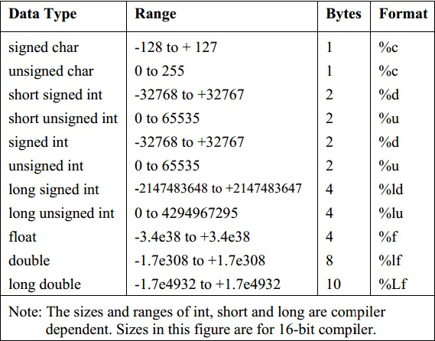

**Difference** in **size** of **Char**:

Since **C** only supports ASCII (English), 1 **byte** is enough for **char** (256 **characters**; 0 to 255). Since **Java** supports more than 18 international languages with over 3200 **characters**, a **char** variable is assigned a space of 2 **bytes** (2^16 = 65536 **characters**). 1:08:40

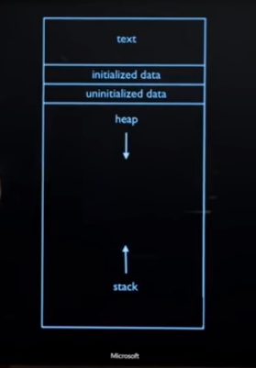

assign memory space(malloc), heap continues to fill, assign functions and from stack it starts to fill. Since memory has a finite of space available, there will always be possibility of overflowing a heap, over overflowing a stack, hence the name stack overflow.

Stack overflow means calling too function that it eventually overlaps heap and other memory parts that will lead to segmentation fault, buffer overflow.

1. **Data Structures(week4)**

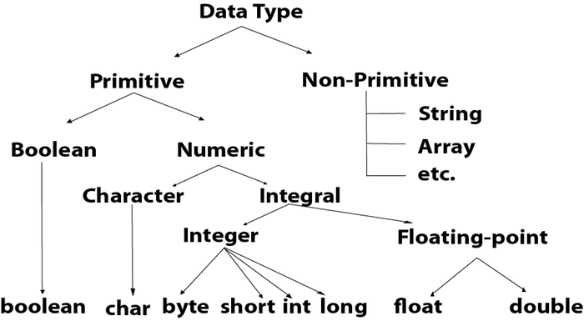

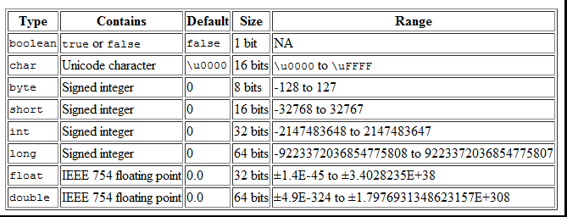

Memory allocation error

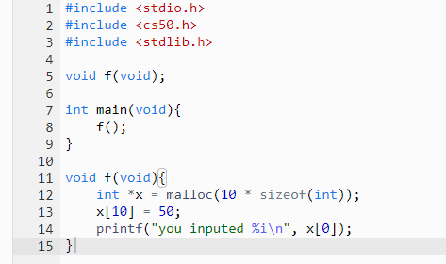

There is no 10th place of a x.

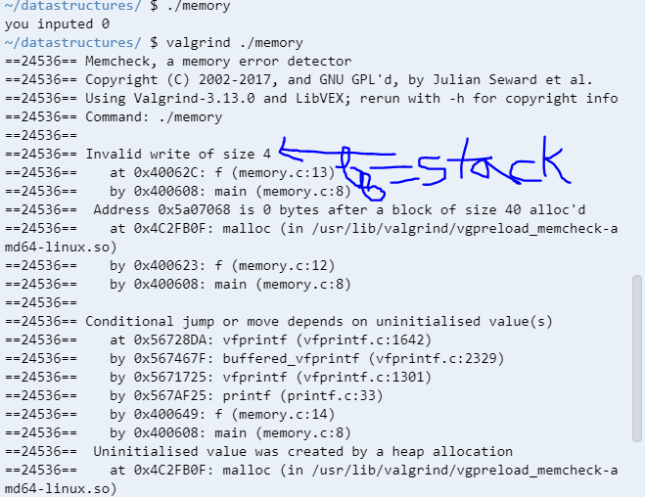

Using valgrind, we could see that invalid size of 4 bit was assigned starting at line 13 function down to 8th function, reading stack from top to bottom). 4bit is int size we assigned.

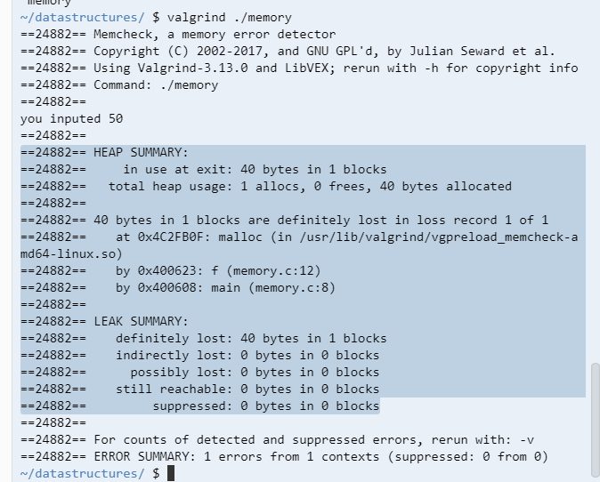

Fixed the issue but there is still an error stating that 40 bytes in 1 block is still at a loss. 40 bytes is the memory size we have given to a int x, 10 memory space for int which is 40 bytes. To fix this, we free the memory once it has been all used.

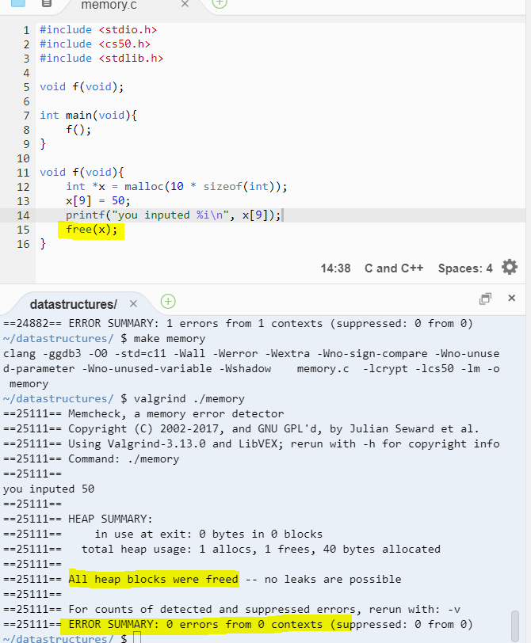

Tadam!

Text - ./ machine codes

Heap – malloc

Stack – functions

LinkedList asks malloc for two spaces, one for data and one for an address.

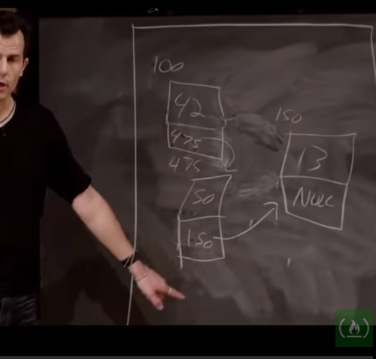

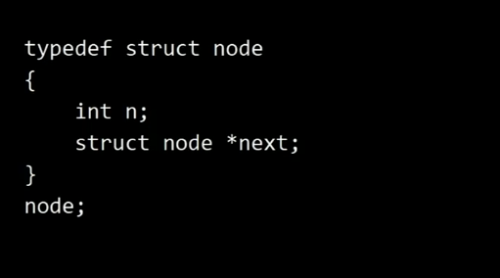

List1 2

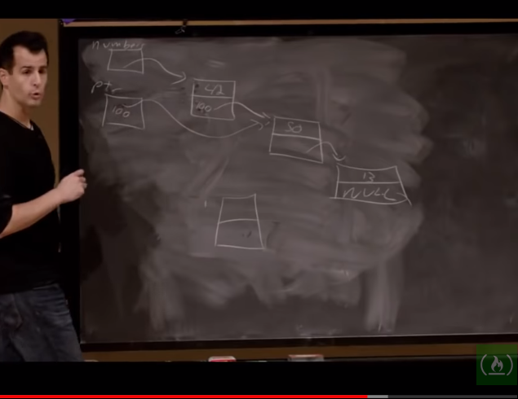

Tri – a tree like data structure but every node is an array. Returns constant time but requires a lot of memory. Sacrifice memory for time efficiency which is perfect for today’s computers, a perfect example could be dictionary.